|  |  |  |  |  |  |  |
| --- | --- | --- | --- | --- | --- | --- |
| **TABLE OF CONTENTS** | | | | | | |
|  | | | | | **Page No.** | |
| **Acknowledgement…………………………………………………………………….….i** | | | | | | |
| **Abstract…………………………………………………………………………………..ii** | | | | | | |
| **List of Figures……………...……………………………………………………………iii** | | | | | | |
| **List of Tables..……………..……………………………………………………………iv** | | | | | | |
| **List of Abbreviations….…………………………………………………………………v** | | | | | | |
| **CHAPTER 1** **Introduction** | | | | | | |
|  | | 1.1 | | Introduction | | 2 |
|  | | 1.2 | | Research Definition | | 3 |
|  | | 1.3 | | Problem Description | | 4 |
|  | | 1.4 | | Motivation | | 5 |
|  | | 1.5 | | Scope and Objectives | | 6 |
|  | | 1.6 | | Planning | | 7 |
|  | | 1.7 | | Organization of Thesis | | 8 |
| **CHAPTER 2 Literature Review & Comparative study** | | | | | | |
|  | | 2.1 | | Evolution of the topic | | 10 |
|  | | 2.2 | | Background Study (Theoretical and Mathematical Background) | | 11 |
|  | | 2.3 | | Review Previous Research Findings | | 14 |
|  | | 2.4 | | Comparative Study | | 17 |
|  | | 2.5 | | Open Issues (Research Gaps) | | 25 |
| **CHAPTER 3 Experimentation/simulation/ Lab Set Up** | | | | | | 26 |
| **CHAPTER 4 Proposed Hypothesis/ Model/ Algorithm** | | | | | | 30 |
|  | 4.1 | | Algorithm | | | 31 |
|  | 4.2 | | Unified Modeling and Visual Representation of the system | | | 33 |
|  | 4.3 | | Implementation Details (Tools and Technologies used), Complexity Analysis, Innovation in Research, Application(s), Use Case(s) and Utilities | | | 35 |
| **CHAPTER 5 –Results and Discussion on Results 37** | | | | | | |
| **Visual Representations of Results and Comparison with Benchmarks** | | | | | | |
| **CHAPTER 6 - Conclusion 41** | | | | | | |
| **CHAPTER 7 - Future Extensions 41** | | | | | | |
| **Bibliography…………………………………………………….42** | | | | | | |
|  | | (Book / Web-link / Journal /Articles/Magazine/online course/online video lectures/ References)  Referencing in the thesis should be as per any one of the internationally accepted Referencing System (Harvard System/APA System/Vancouver System/Oxford/Footnote.....etc) | | | |  |
| **AI-Plagiarism Report** | | | | | | 44 |
| **Research Paper(s) publication, if any** | | | | | |  |

**ACKNOWLEDGEMENT**

I would like to express my profound gratitude to all those who have contributed to this research project, titled *"*Vehicular Ad Hoc Network: Improving Routing Reliability of AODV Protocol*."*

First and foremost, I extend my heartfelt thanks to my mentor and guide, Dr. Ritesh Patel, for their invaluable guidance, encouragement, and constructive feedback throughout the course of this research. Their expertise and insights have been instrumental in shaping the direction and depth of this study.

I am deeply grateful to U & P U Patel Department of Computer Engineering Faculty of Technology & Engineering (FTE), CHARUSAT Chandubhai S. Patel Institute of Technology (CSPIT) Changa, Anand for providing the resources, facilities, and a supportive environment that made this research possible. I would also like to thank my professors and colleagues for their valuable discussions and suggestions, which enriched the quality of this work.

A special thanks to my family and friends for their unwavering support and encouragement, without which this journey would have been incomplete. Their belief in my abilities kept me motivated throughout.

Lastly, I would like to acknowledge the authors of previous studies and the open-source tools and technologies that formed the foundation of my work. Their contributions to the field have inspired and informed this research endeavour.

Thank you all for being a part of this journey.

Sincerely,  
Prajesh Prajapati

**ABSTRACT**

Vehicular Ad Hoc Networks (VANETs) play a crucial role in modern intelligent transportation systems by enabling efficient communication between vehicles and infrastructure. However, the dynamic and highly mobility nature of VANETs creates significant challenges for routing protocols, often resulting in unreliable communication. The Ad Hoc On-Demand Distance Vector(AODV) protocol, a widely used routing protocol, is particularly susceptible to issues like frequent route disruptions, packet loss, and increased latency. These challenges hinder its effectiveness in maintaining reliable communication in vehicular environments.

Routing reliability in VANETs is a critical area of research due to its impact on traffic safety and network performance. Many studies have explored enhancements to AODV and other protocols to address these challenges. Recently, automated and adaptive techniques have been proposed to improve routing performance. This paper focuses on routing reliability in VANETs, particularly the limitations and challenges associated with the AODV protocol. It aims to provide a comprehensive review of existing research, highlighting the key challenges and potential directions for improvement.

The study also discusses various simulation tools and frameworks used for evaluating routing protocols in VANETs, offering insights into methodologies and metrics that researchers can leverage to further investigate and improve routing reliability. This review serves as a foundation for future work, emphasizing the importance of developing robust and scalable solutions for vehicular communication systems.

**LIST OF TABLES**

Table 1: Planning

Table 2: Simulation tool and environment

Table 3: Technologies Used

Table 4: Use Case and Utilities

**LIST OF FIGURES**

Fig 1: AODV Protocol

Fig 2: Format of Forward Ant Message

Fig 3: Format of Backward Ant Message

Fig 4: Route request Message Format

Fig 5: Multiple Criteria Decision Making Metrix

Fig 6: Flowchart of E-AODV

Fig 7: Flowchart of Proposed ACO technique

Fig 8: VANET Panigate Scenario

Fig 9: Proposed Algorithm

Fig 10: Packet Delivery Ratio vs Number of Nodes

Fig 11: End to End Delay vs Number of Nodes

Fig 12: Routing Overhead vs Number of Nodes

Fig 13: Throughput vs Number of Nodes

**ABBREVIATIONS**

VANET - Vehicular Ad Hoc Network

MANET- Mobile Ad Hoc Network

AODV - Ad Hoc On-demand Vector

ITS - Intelligent Transport System

V2V - Vehicle to Vehicle

V2I - Vehicle to infrastructure

DSRC - Dedicated Short-range Communication

DSR - Dynamic Source Routing

OLSR - Optimized Link State Routing

RREQ -Route Request

RREP - Route Reply

RERR- Route Error

PDR – Packet delivery Ratio

NS-3 – Network Simulator 3

SUMO – simulation of Urban Mobility

TOPSIS – Technique for Order of Preference by Similarity to ideal Solution

E2E –End to End delay

CW – Contention Window

LBFI – Link breakage forecasting indicator

OFDM – Orthogonal Frequency Division Multiplexing

ACO –Ant Colony Optimization

RSU – Rode Side Unit

IOT – Internet of Things

MCDM – Multiple Criteria Decision Making

**CHAPTER 1**

**INTRODUCTION**

**1.1 Introduction**

Vehicular Ad Hoc Networks (VANETs) have emerged as a pivotal component of Intelligent Transportation Systems (ITS), aimed at enhancing road safety, traffic efficiency, and providing infotainment services. In a VANET, vehicles equipped with wireless communication devices act as nodes in a dynamic network, enabling vehicle-to-vehicle (V2V) and vehicle-to-infrastructure (V2I) communication without relying on fixed infrastructure. This highly mobile and rapidly changing network environment necessitates the use of efficient and reliable routing protocols.

One of the most widely studied and implemented routing protocols for ad hoc networks is the Ad hoc On-Demand Distance Vector (AODV) routing protocol. AODV operates on an on-demand basis, establishing routes only when required by source nodes, thus minimizing overhead. It maintains routes as long as they are needed and deletes them when no longer in use, making it well-suited for dynamic topologies.

However, the application of AODV in VANETs presents unique challenges. The high mobility of vehicles leads to frequent link breakages, rapid topology changes, and unpredictable network behavior. These conditions often result in decreased Packet Delivery Ratio (PDR), increased end-to-end delay, and elevated routing overhead, thereby reducing the overall reliability and efficiency of communication.

Recognizing these challenges, this research aims to investigate and propose modifications to the traditional AODV protocol to enhance its reliability within VANET environments. By integrating link stability estimation and predictive route maintenance mechanisms, the proposed work seeks to reduce the impact of link failures and improve the robustness of data transmission.

The enhanced AODV is expected to provide more stable routing paths, lower packet loss rates, and better adaptability to high-speed vehicular scenarios. The research includes simulation-based evaluation using realistic mobility models to validate the effectiveness of the proposed improvements.

**1.2 Research Definition**

The research focuses on improving the route stability in Ad hoc On-Demand Distance Vector protocol within the context of Vehicular Ad Hoc Networks (VANETs). In its conventional form, AODV establishes routes between nodes dynamically but struggles under the high mobility and rapid topology changes characteristic of vehicular environments. Frequent link breakages lead to route discovery overheads, increased latency, and lower packet delivery success, which are critical drawbacks for applications that require real-time and reliable communication.

The core research problem is to identify the limitations of standard AODV in VANET scenarios and develop an improved version that can adapt to high mobility without significantly increasing routing overhead or computational complexity. The central hypothesis is that integrating link stability metrics and predictive route maintenance strategies into AODV will lead to a notable improvement in overall network performance, particularly in terms of packet delivery ratio, end-to-end delay, and route stability.

Thus, the research is defined by the following key objectives:

* Analyze the performance gaps of standard AODV in dynamic vehicular environments.
* Design and propose modifications to AODV focused on enhancing route stability.
* Implement the modified protocol using network simulation tools (e.g., NS-3).
* Evaluate and compare the performance of the proposed method against the standard AODV protocol using realistic vehicular mobility models.

The ultimate aim of the research is to contribute a scalable, efficient, and reliable routing solution that can support the evolving demands of VANET-based applications in intelligent transportation systems.

**1.3 Problem Description**

Vehicular Ad Hoc Networks (VANETs) are characterized by highly dynamic topologies, frequent network disconnections, rapid node mobility, and variable communication environments. In such conditions, maintaining stable and reliable communication links becomes extremely challenging. Efficient routing protocols are critical for supporting various safety, traffic management, and infotainment applications in VANETs.

The Ad hoc On-Demand Distance Vector (AODV) protocol, although widely used in traditional Mobile Ad Hoc Networks (MANETs), faces significant limitations when directly applied to VANETs. AODV establishes routes on demand and maintains them for a fixed, pre-defined route lifetime, irrespective of real-time network dynamics. This static route lifetime setting introduces several problems in vehicular environments:

* **Frequent Link Breakages**: Due to high-speed vehicle movement, established links often become invalid much earlier than the pre-set route lifetime, leading to frequent link failures.
* **High Routing Overhead**: Route failures trigger repeated route discovery processes, significantly increasing control message overhead and network congestion.
* **Reduced Packet Delivery Ratio (PDR)**: Unreliable routes cause packet losses, reducing the overall efficiency of data delivery, especially critical for real-time and safety applications.
* **Increased End-to-End Delay**: Route rediscovery delays the packet forwarding process, resulting in higher end-to-end transmission delays.
* **Static Route Lifetime Inefficiency**: In a highly dynamic vehicular environment, a fixed route expiration time does not reflect the actual stability or mobility of links, leading to inefficient route maintenance.

Given these challenges, there is a pressing need for an adaptive routing mechanism that can dynamically adjust to the fast-changing vehicular network conditions. Specifically, there is a need to enhance AODV by:

* Monitoring real-time link stability.
* Adjusting route lifetimes dynamically based on mobility patterns and connection quality.
* Minimizing unnecessary control overhead while improving communication reliability.

Addressing this problem is crucial for ensuring that VANET applications, especially those related to road safety and traffic management, can operate effectively and reliably under practical deployment conditions.

**1.4 Motivation**

The modern world is increasingly moving towards intelligent transportation systems (ITS), where vehicles are no longer isolated units but are interconnected, sharing real-time information to enhance road safety, traffic efficiency, and driving comfort. Vehicular Ad Hoc Networks (VANETs) form the technological backbone of these systems, enabling vehicles to communicate directly with each other and with roadside infrastructure.

However, the effectiveness of VANETs is heavily dependent on the reliability of the underlying routing protocols. In high-mobility scenarios, such as highways or urban traffic environments, maintaining a consistent and efficient communication path becomes extremely challenging. The Ad hoc On-Demand Distance Vector (AODV) protocol, while effective in conventional mobile networks, often fails to deliver consistent performance in vehicular networks due to frequent route failures and high topology dynamics.

The motivation for this research arises from several pressing needs:

* **Safety-Critical Applications**: Life-saving applications like collision avoidance, emergency vehicle notification, and hazard alerts require highly reliable and low-latency communication.
* **Real-Time Data Dissemination**: Traffic management systems depend on the timely and accurate exchange of data, necessitating robust routing even under fast-changing network conditions.
* **Limitations of Traditional AODV**: The inability of AODV to predict and adapt to link instability leads to poor performance in VANETs, creating an urgent need for improvement.
* **Research Gaps**: Existing improvements often focus either on minimizing overhead or optimizing for static environments; few directly address **mobility prediction** and **link stability** in routing.
* **Future Transportation Needs**: As autonomous and connected vehicles become more prevalent, ensuring reliable vehicular communication will be a key enabler of innovation and public trust.

Thus, enhancing AODV to be more resilient, link-aware, and adaptive to mobility patterns is not just an academic exercise but a crucial step towards realizing safer and smarter transportation networks.

**1.5 Scope and Objectives**

**Scope**

This research seeks to enhance the route dependability of the AODV protocol, placing particular focus on its use in Vehicular Ad Hoc Networks (VANETs). The project's scope is limited to the following domains:

* **Protocol Enhancement**: The work centers around modifying the existing AODV protocol by introducing a dynamic route lifetime adjustment mechanism based on real-time vehicular mobility and link stability conditions.
* **Simulation-Based Validation**: The enhanced protocol is implemented and tested using network simulation tools (specifically NS-3) with realistic vehicular mobility models generated via SUMO (Simulation of Urban Mobility).
* **Performance Metrics**: The protocol’s performance will be evaluated based on key Quality of Service (QOS) parameters such as Packet Delivery Ratio (PDR), End-to-End Delay, and Routing Overhead.
* **Comparative Analysis**: The results of the proposed enhanced AODV protocol will be compared against the standard AODV protocol under similar network conditions to validate improvements.
* **Research Focus**: The work does not cover security enhancements, cross-layer design considerations, or deployment on real-world vehicular platforms. It strictly focuses on routing reliability improvements at the network layer.

**Objectives**

The goal of this paper is to increase the adaptability and stability of the AODV protocol in dynamic environments in order to develop and assess an improved routing strategy for Vehicular Ad Hoc Networks (VANETs). By integrating real-time metrics that represent the state of the network, such as vehicle speed, signal strength (RSSI), transmission delay, and congestion, the proposed study aims to develop a more resilient routing mechanism. In order to create more durable and stable routes, this study aims to create a dynamic neighbor selection method based on a composite dependability score. Implementing and simulating this enhanced protocol, known as R-AODV, utilizing NS-3 and SUMO to replicate actual vehicle behavior is another important goal. In order to demonstrate R-AODV's applicability for highly mobile and dynamic VANET situations, the study will lastly compare its efficacy to that of the conventional AODV utilizing quantitative performance indicators.

**1.6 Planning**

Effective planning is essential for the successful completion of this research project. The project has been organized into systematic phases, with specific tasks assigned to each phase to ensure structured progress and timely delivery. The overall plan is designed to cover literature review**,** design**,** implementation**,** testing**,** anddocumentation stages over a targeted timeframe of approximately 12–14 months.

**Phases of Planning**

|  |  |  |
| --- | --- | --- |
| **Phase** | **Duration** | **Tasks** |
| Phase 1: Preliminary Research and Problem Identification | 2.5 months | - Study VANET fundamentals and AODV protocol behavior.  - Identify limitations of AODV in vehicular scenarios.  - Finalize project objectives and scope. |
| Phase 2: Literature Review and Gap Analysis | 2 months | - Conduct a detailed literature review of existing enhancements to AODV and other VANET routing protocols.  - Identify research gaps and finalize proposed modifications. |
| Phase 3: System Design and Algorithm Development | 3 months | - Design a modified AODV protocol incorporating link stability and predictive mechanisms.  - Develop system architecture and UML models. |
| Phase 4: Simulation Setup and Implementation | 2 months | - Set up simulation environment using NS-3 and SUMO.  - Implement the proposed algorithm.  - Integrate realistic vehicular mobility models. |
| Phase 5: Experimentation and Performance Analysis | 1.5 months | - Conduct extensive simulation experiments.  - Collect and analyze data for packet delivery ratio, delay, and overhead.  - Compare results with standard AODV benchmarks. |
| Phase 6: Documentation and Thesis Writing | 1 months | - Prepare the complete project report including all chapters, results, and discussions.  - Create visual graphs, tables, and diagrams for results representation. |
| Phase 7: Final Review and Submission | 1 months | - Review the complete project for consistency, formatting, and plagiarism compliance.  - Submit the final project report and research paper (if applicable). |

Table 1: Planning

* 1. **Organization of Thesis**

This thesis is organized into seven structured chapters, each designed to systematically present the research problem, methodology, experimentation, results, and future work. A brief outline of each chapter is as follows:

Chapter 1: Introduction Provides an overview of Vehicular Ad Hoc Networks (VANETs), the importance of reliable routing, the limitations of the AODV protocol in high-mobility environments, and defines the research problem, motivation, scope, objectives, planning, and the overall organization of the thesis. Chapter 2: Literature Review as well as Comparative Study presents a detailed survey in existing research related to VANETs as well as AODV improvements. It covers the theoretical background, reviews prior work, compares different routing protocols, and identifies research gaps that motivate the proposed work. Chapter 3: Experimentation / Simulation / Lab Setup Describes the simulation environment, tools (such as NS-3 and SUMO), mobility models, network parameters, and performance metrics used to validate the proposed enhancements. Chapter 4: Proposed Hypothesis / Model / Algorithm Introduces the proposed improvements to the AODV protocol, detailing the newly integrated link stability and predictive route maintenance techniques. It also explains system modeling using Unified Modeling Language (UML) diagrams, implementation details, complexity analysis, and possible applications. Chapter 5: Results and Discussion on Results Presents the simulation outcomes, including graphs, tables, and comparative analysis between the standard and enhanced AODV protocols. The chapter discusses the significance of the improvements in terms of Packet Delivery Ratio, End-to-End Delay, and Routing Overhead. Chapter 6: Conclusion Summarizes the major findings of the research, highlighting how the proposed solution improves the performance of VANET communications and addresses the initial research problem. Chapter 7: Future Extensions Suggests potential directions for extending this research, including the integration of machine learning techniques, energy-efficient routing strategies, and real-world hardware implementation possibilities.

Additionally, the thesis concludes with a Bibliography citing all the references used, an AI-Plagiarism Report ensuring the originality of the work, and documentation of Research Paper(s) publication, if any.

**CHAPTER 2**

**LITERATURE REVIEW & COMPARATIVE STUDY**

**2.1 Evolution of the topic**

Intelligent transportation systems and smart mobility solutions have been made possible by the development of Vehicular Ad Hoc Networks (VANETs). The concept of self-organizing, infrastructure-less networks was adapted for the vehicular environment, where nodes (vehicles) exhibit high mobility and frequent topological changes, by VANETs, which are based on the Mobile Ad Hoc Networks (MANETs) concept.

Basic communication needs for road safety, such as warning messages and accident alerts, were the main focus of VANET research in its early stages. The scope expanded to accommodate infotainment, traffic efficiency, and autonomous vehicle communication as technology developed. More reliable and scalable communication protocols that could manage changing network behaviors were needed to meet these objectives.

The on-demand structure of routing protocols like AODV led to their early adoption; however, high node mobility and erratic connectivity caused them to perform poorly in VANET environments. Researchers gradually began adding location awareness, mobility prediction, and link stability checks to AODV and related protocols. Nevertheless, real-time communication issues including congestion, signal quality, and delay were not addressed in many enhancements.

This led to the current research focus: creating intelligent routing techniques that integrate context-aware and real-time measurements to improve route stability and data delivery. The current study builds on this development by presenting an improved AODV protocol that dynamically assesses node dependability, thereby strengthening the resilience of routing choices in VANET systems.

**2.2 Background Study (Theoretical and Mathematical Background)**

A specific subclass of mobile ad hoc networks (MANETs), vehicular ad hoc networks (VANETs) are designed to facilitate communication in highly dynamic automotive contexts. VANETs form the basis of modern Intelligent Transportation Systems (ITS), enabling communication between vehicles and infrastructure, as well as between vehicles and other vehicles. Their distinct characteristics, which differentiate them from conventional MANETs and pose specific challenges for routing protocols, include significant node mobility, rapidly changing network topologies, and transient communication links.

The Ad Hoc On-Demand Distance Vector (AODV) protocol is one of the most popular routing methods in VANET settings. A reactive routing protocol called AODV was developed for dynamic environments, such as those in automotive and mobile networks. It minimizes the overhead involved in keeping routing tables updated at all times by only establishing routes when necessary. Because it operates on demand, AODV is particularly well-suited for networks like VANETs that experience constantly changing topologies.

**Key Features of AODV Protocol**

* **On-Demand Route Discovery**: AODV initiates route discovery only when a source node needs to communicate with a destination node. This reduces unnecessary routing updates and limits the volume of control messages compared to proactive protocols.
* **Sequence Numbers for Route Freshness**: To ensure loop-free and up-to-date routing information, AODV employs sequence numbers. These numbers help identify the most recent path to a destination, thus preventing the use of outdated routes.
* **Dynamic Route Maintenance**: Active routes are maintained as long as they are in use. If a route becomes invalid due to link failure, the protocol promptly notifies affected nodes, allowing for immediate reconfiguration in response to topology changes.
* **Support for Bidirectional Links**: AODV ensures valid two-way communication between source and destination nodes, confirming that links are reliable in both directions before data transmission begins.
* **Moderate Scalability**: While AODV performs efficiently in small to medium-sized networks, its scalability may be limited in large-scale or highly mobile environments, as increased control message traffic can degrade performance.

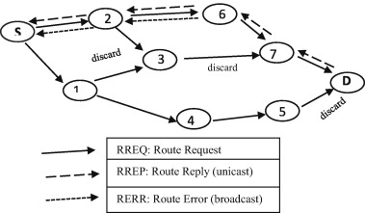

Fig 1: AODV Protocol

**Working of the AODV Protocol**

The operation of the Ad Hoc On-Demand Distance Vector (AODV) protocol can be divided into three primary phases:

**Route Discovery**

When a source node needs to send data to a destination node for which it has no valid route, it initiates the route discovery process by broadcasting a Route Request (RREQ) packet to its neighboring nodes. Each intermediate node that receives this packet checks its routing table:

* If it does not have a valid route to the destination, it rebroadcasts the RREQ.
* If it does have a valid and fresh route, it replies to the source node with a Route Reply (RREP) packet.

Once the RREQ reaches the destination node (or an intermediate node with a valid route), an RREP is sent back along the reverse path to the source. This establishes a temporary route for data transmission.

**Route Maintenance**

During data transmission, if a link break is detected, such as when a vehicle moves out of communication range, the intermediate node that detects the failure generates a Route Error (RERR) packet. This RERR is propagated back to the source node, informing it of the broken link. Upon receiving the RERR, the source node can initiate a new route discovery process if it still needs to communicate with the destination.

**Route Deletion**

When a route becomes inactive either because it is no longer being used or has been invalidated due to topology changes, it is removed from the routing table. This helps conserve memory and computational resources on each node, keeping the routing tables lean and efficient.

**Mathematical Background**

The performance of routing protocols like AODV in VANETs can be assessed using mathematical models and performance metrics, which consist of:

**Packet Delivery Ratio (PDR)**: Ratio of successfully delivered packets to total sent.

**PDR =**



**End-to-End Delay**: Average time taken for packets to reach the destination.

**Delay =**



**Routing Overhead**: Number of control packets transmitted per data packet.

**Overhead =**



**Throughput**: The rate of successful data delivery over a communication channel.

**Throughput =**



**Technological Background**

Routing protocol development, such as AODV, relies on simulation tools to evaluate performance in VANETs:

* **NS-3**: Simulates network-level behavior and protocol performance.
* **SUMO:** Models realistic vehicle mobility in urban and highway scenarios.

**2.3 Review Previous Research Findings**

Routing protocols for Vehicular Ad Hoc Networks (VANETs) have been extensively studied, with particular attention paid to the difficulties presented by high mobility, dynamic topologies, and frequent link failures. Because of its reactive and adaptive features, the Ad Hoc On-Demand Distance Vector (AODV) protocol has attracted a lot of interest in these investigations. This section covers major findings from earlier research on AODV in VANETs, noting breakthroughs, persisting issues, and gaps in the present body of literature.

1. **Performance Study of AODV Protocol with Ant Colony Algorithm in VANETs**

This article presents an upgrade to the Ad hoc On-Demand Distance Vector (AODV) routing protocol by incorporating the Ant Colony Algorithm to enhance its performance in Vehicular Ad-hoc Networks (VANETs). The proposed new-AODV protocol aims to reduce packet loss and improve network stability by utilizing pheromone fields to identify reliable and efficient connections. According to experimental findings, new-AODV outperforms the conventional AODV protocol regarding network stability and packet loss rate [1].

1. **Improving AODV with TOPSIS Algorithm and Fuzzy Logic in VANETs**

To reduce end-to-end latency and increase throughput compared to the standard AODV protocol, the authors propose a technique where each vehicle employs the Technique for Order of Preference by Similarity to Ideal Solution (TOPSIS) algorithm to select the most reliable neighbors for transmitting path requests. Then, the destination vehicle utilizes a fuzzy logic algorithm to identify the optimal route from the received paths [2]. Simulation results indicate that this novel technique provides improved performance, with reduced latency and increased throughput.

1. **Modifications of AODV protocol for VANETs: performance analysis in NS-3 simulator**

Using Network Simulator 3 (NS-3), the Probabilistic AODV (PAODV) protocol—an adaptation of AODV for Mobile Ad Hoc Networks (MANET)—and its version, Neighbor PAODV (Nb-PAODV), were evaluated in an urban VANET setting. Throughput, packet loss ratio, useful traffic ratio, maximum, median, and average end-to-end delay (E2E), as well as jitter, were among the performance indicators used to examine the simulation findings. To find the best settings, the PAODV protocol was tested using various probability parameters. Findings revealed that the Nb-PAODV protocol outperformed PAODV in several critical measures, particularly in terms of E2E delay [3].

1. **Performance analysis of AODV and EDAODV routing protocol under congestion control in VANETs**

In this study, we evaluate the efficacy of a routing protocol known as Early Congestion Detection and Control (EDAODV) against the Ad Hoc On-demand Distance Vector (AODV) Routing protocol, which lacks a congestion control mechanism in the network. We performed our simulations with NS2 and examined the results between these two protocols as the node count increases [4].

1. **End-to-End Delay Enhancement with Ring Cluster AODV in VANET**

This document introduces a temporary adjusted AODV (TM-AODV) routing protocol designed to reduce end-to-end delay. A study comparing the performance of AODV and TM-AODV has been conducted utilizing the Sumo and NS2 simulators, highlighting IEEE 802.11p and IEEE 802.11g as MAC protocols in relation to different traffic densities and vehicle speeds in urban and highway environments. The findings indicate that TM-AODV outperforms AODV regarding throughput and end-to-end latency. This paper aims to explore methods for enhancing the efficiency of AODV by creating stable clusters and utilizing Gateway nodes and Cluster Heads for routing [5].

1. **Enhancement AODV Routing Protocol at the VANET within an Urban Scenario**

This study presents an enhanced version of the AODV routing protocol designed specifically for VANETs. The research assesses how adjusting the Contention Window (CW) settings based on traffic density can improve the performance of 802.11p transmission regarding reception rates and latency. Our findings indicate that the CW defined in the IEEE 802.11p standard exhibits strong performance in nearly all assessed scenarios. Moreover, the suggested protocol (P-AODV) demonstrates robustness in rapidly changing environments with varying traffic densities and movement behaviors [6].

1. **A new AODV based forecasting link breakage indicator for VANETs**

The Link Breakage Forecasting Indicator (LBFI), a novel replacement for the conventional route breakage detection technique in AODV, is presented by the authors of this paper. LBFI uses Dempster-Shafer belief theory and information from the OFDM packet decoding process to anticipate link problems before they occur. This proactive strategy aims to decrease end-to-end delay, increase the packet delivery ratio, and improve route reliability. Using the NS-3 network simulator, the recently proposed protocol, LBFI-AODV, is evaluated and demonstrates notable performance improvements over the conventional AODV protocol [7].

1. **The Development of a Routing protocols based on Reverse-AODV by considering an energy threshold in VANET**

This document introduces two novel protocols: E-AODV and RE-AODV, which incorporate the concept of "minimum residual energy" as an energy threshold in VANET. The E-AODV and RE-AODV protocols aim to enhance network efficiency by tackling node battery exhaustion and optimizing the broadcasting and filtering of route request (RREQ) messages based on energy limits. When intermediary nodes run out of energy because of low battery levels during the request and response stages, they might drop data packets or messages, potentially harming the protocol's efficiency [8].

1. **Enhanced New Clustering Ant Colony Optimization based Routing Protocol AODV-R**

This research examines the benefits of the AODV-R routing protocol concerning reliability. It introduces a new routing protocol called AODV-R, which leverages Ant Colony Optimization and clustering to enhance route reliability, packet delivery ratio, control overhead, end-to-end delay, and link failures. This is achieved by using clustering methods to lower energy usage during data transmission and applying ACO to determine the most efficient route between nodes. The suggested technique has demonstrated considerable improvements when compared to current methods [9].

**2.4 Comparative Study**

This section delves into the implementation details of the AODV protocol within VANET environments, focusing on the tools, methodologies, and approaches used in previous studies to evaluate and enhance its performance.

1. **Performance Study of AODV Protocol with Ant Colony Algorithm in VANETs**

The forward ant message and the backward ant message are the two types of messages introduced in the study under the new-AODV protocol. These messages work similarly to the conventional AODV protocol's Route Request and Route Reply messages, but they have additional fields added to incorporate the ant colony algorithm.

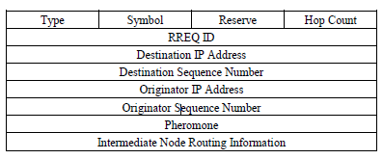

Fig 2: Format of Forward Ant Message

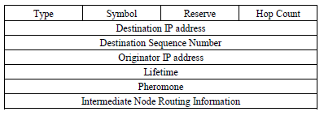

Fig 3: Format of Backward Ant Message

**Route Construction and Trail Updating**

In order to determine whether a legitimate path to the destination exists, the source node first consults its routing database. The source node sends a forward ant message to its nearby nodes and sets an initial pheromone value if no route is detected. An intermediate node checks its routing table for a legitimate path to the destination after receiving the forward ant packet. The route is disregarded if the forward ant message's pheromone level falls below a specified minimum threshold. On the other hand, the path to the source node is altered and the route is revised if the pheromone level surpasses the threshold. The forward ant packet is then transmitted to nearby nodes, updating the pheromone value according to predetermined formulas.

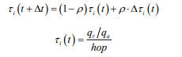

The message's initial pheromone level is represented by the variable τi(t), and the updated pheromone value is indicated by τi(t+∆t). The pheromone volatility and its rate of evaporation are defined by the parameter ρ, which is a fixed constant that lies between 0 and 1. The length of the receive queue at node I is represented by the variable qa, while the length of the unused portion is denoted by the variable qr.

The intermediate node modifies the packet's pheromone value as the backward ant communication moves from the destination to the source. The source node determines the optimal route to the destination by analyzing the pheromone values after receiving several backward ant signals. To dynamically update the routing table, the source node sends forward ant messages regularly.

**Backup Routing Mechanism**

A node saves the feasible routes as backup paths in its routing pheromone table when it receives several backward ant signals from the destination to the source. The node initiates the alternative route from the table to restore the connection and carry on data transmission in the event that the primary path malfunctions or performs poorly. This method increases the network's stability and reliability by ensuring that a backup path is always available.

1. **Improving AODV with TOPSIS Algorithm and Fuzzy Logic in VANETs**

Route request messages are broadcast by source and intermediate vehicles in the traditional AODV protocol, which increases routing overhead. The proposed approach, on the other hand, minimizes this overhead by employing the TOPSIS algorithm to select the most reliable neighbor.

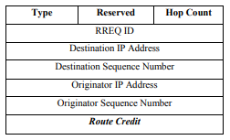

Fig 4: Route request Message Format

Four criteria are used by the Multiple Criteria Decision Making framework to evaluate and choose the best neighbors for routing: average delay, relative speed, congestion, and received signal strength.

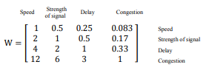

Fig 5: Multiple Criteria Decision Making Metrix

The source vehicle only forwards the RREQ message to its most trustworthy neighbors, as identified by the TOPSIS algorithm, rather than disseminating it widely. By rejecting neighbors that have previously passed the message, each intermediary vehicle selects its most trustworthy neighbors to send the RREQ message, preventing loops.

Multiple RREQ messages are sent to the destination vehicle from different paths. It logs the route data and applies a fuzzy algorithm to choose the best path based on three criteria: Route Legitimacy, Hop Count, and Delay. These factors are processed by the fuzzy algorithm to choose the most dependable course of action. An RREP message is then sent along the selected path by the destination vehicle.

1. **Modifications of AODV protocol for VANETs: performance analysis in NS-3 simulator**

To enhance the effectiveness of the Ad hoc On-Demand Distance Vector protocol in Vehicular Ad hoc Networks, the paper outlines modifications to the protocol. Among these changes are:

**Probabilistic AODV**: This version adjusts the likelihood of sending Route Request (RREQ) packets based on network density. While the probability is increased in sparse networks to enhance the likelihood of successful route discovery, it is decreased in dense networks to save overhead.

Avg =



**Neighbor PAODV**: By considering the number of surrounding nodes connected to a specific node, this improvement evaluates the likelihood of RREQ packet rebroadcasting. By removing the need to assess network density beforehand, this method enhances efficiency in real-world situations.

p =



According to simulation studies, Nb-PAODV outperforms both PAODV and regular AODV, especially in high-vehicle-density metropolitan environments. It reduces overhead and improves important performance indicators, such as jitter and end-to-end delay.

1. **Performance analysis of AODV and EDAODV routing protocol under congestion control in VANETs**

The Early Congestion Detection and Control Routing Protocol (EDAODV) is an on-demand routing protocol specifically developed for Vehicular Ad-Hoc Networks (VANETs). Its purpose is to tackle congestion issues in these networks, which can cause packet loss and extended delays. EDAODV was designed to detect congestion early and manage it by finding alternative paths within VANETs. When congestion is detected, it uses a bidirectional approach to find a different route linking the source and destination nodes. The source node broadcasts a Route Request (RREQ) message to find a route to the intended destination. Each node maintains both a primary and a backup routing table. Congestion is identified based on various factors, including buffer capacity. Nodes anticipate traffic jams and transmit status packets to keep their routing tables updated. To locate a non-congested alternate path when congestion is detected, nodes utilize Bidirectional Route Request (BIRREQ) and Bidirectional Route Reply (BIRREP) messages.

For example, imagine a primary route from source to destination with four intermediate nodes S-1-2-3-4-R. After some time, node 2 detects a potential congestion and issues a warning message to its neighboring nodes, 1 and 3. In an effort to establish a bidirectional route that avoids node 2, these nodes send BIRREQ messages to other nearby nodes, and suppose they discover that node A is free of congestion. When node A receives this request, it replies with a BIRREP to nodes 1 and 3. Consequently, node 1 acquires an alternate route to R. The data traffic directed to node 1 will now reroute through the path 1-A-3 to reach the destination, changing the route to S-1-A-3-4-R. If an alternate path cannot be found, the data flow continues along the original path S-1-2-3-4-R.

EDAODV manage network congestion more effectively, resulting in fewer packet losses and lower transmission delays compare to AODV.

1. **End-to-End Delay Enhancement with Ring Cluster AODV in VANET**

The TM-AODV protocol aims to enhance the performance of the standard AODV protocol by creating stable clusters and performing routing through Gateway nodes and Cluster Heads.

Clusters are formed with Nodes, and each one is overseen by a Cluster Head. The Cluster Heads control routing data and oversee communication within the cluster. Gateway nodes aid in enabling communication among various clusters. When a source node wants to create a path to a destination node, it sends a Route Request (RREQ) to its Cluster Head. The Cluster Head verifies whether the destination node is located inside its cluster. If the packets are located, they are sent to the destination; if not, the RREQ is sent to the Gateway nodes. When a link failure is identified, a Route Error (RERR) message is created to notify other nodes of the problem. The Cluster Heads and Gateway nodes assist in managing the routes and minimizing the control messages.

1. **Enhancement AODV Routing Protocol at the VANET within an Urban Scenario**

The protocol adjusts the CW configurations to improve the efficiency of IEEE 802.11p communication, specifically targeting reception probabilities and latency. Increasing the contention window (CW) size by two increments from its initial value (CWstart) to a maximum value (CWend) is necessary in order to send a data packet. The CW returns to its initial value when packets are dropped for going over the channel's maximum access limit or when the transmission is successful. Send acknowledgments back to the original node. Hence, a sender is unable to ascertain whether all receiver nodes have successfully received the packet.

The suggested protocol shows strength in very changing settings with different levels of traffic and movement styles. It uses a method based on graphs to forecast routes, taking into account intersections and road segments. The CW size is gradually increased by the protocol to efficiently control packet transmission.

1. **A new AODV based forecasting link breakage indicator for VANETs**

In vehicular ad hoc networks (VANETs), detecting route failures is important because of the frequent link breakages caused by high vehicle mobility. The conventional AODV method utilizes HELLO messages for identifying link failures. When a node doesn't get a HELLO message from a neighbor in a specific time frame, it considers the link broken and notifies the source node with a Route Error (RERR) message. Nevertheless, this technique may lead to lateness and dropped packets.

In order to enhance this, the article suggests implementing a Link Breakage Forecasting Indicator (LBFI) utilizing OFDM packet decoding errors and Dempster-Shafer belief theory. Exploiting OFDM decoding errors brings more information than classical physical information such as the Received Signal Strength Intensity (RSSI) or the Signal to Noise Ratio (SNR). This technique anticipates link failures pre-emptively, enabling the network to identify alternative routes before they happen. Maintaining routes in AODV means identifying alternative paths when the existing ones are no longer functioning. Once the node detects a broken link, it sends a RERR message to the source, which then starts a new route discovery process. The origin node keeps using the existing path while looking for an alternative. When a new path is discovered, the node will change to it to maintain uninterrupted data transfer.

The incorporation of LBFI in AODV improves the process by giving early alerts for link failures, making transitions to new routes easier, and decreasing packet loss and end-to-end delay.

1. **The Development of a Routing protocols based on Reverse-AODV by considering an energy threshold in VANET**

An enhanced version of the AODV routing protocol, E-AODV, was created to address network performance and energy consumption concerns in MANETs and VANETs. It allows for the identification of more stable routes that are less likely to fail due to energy depletion by tracking the minimal remaining energy of nodes along a route. E-AODV reduces control message overhead and conserves power by restricting the broadcasting of RREQ messages, omitting nodes with energy levels below a predetermined threshold.

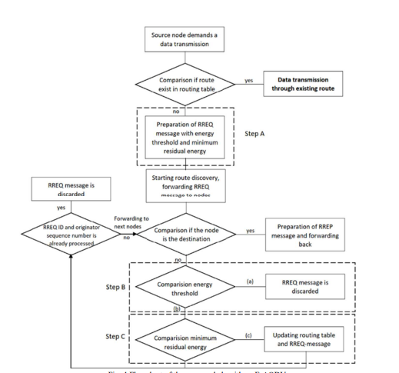

Fig 6: Flowchart of E-AODV

A modified version of the AODV routing protocol, RE-AODV, is intended to increase the dependability and energy efficiency of MANETs and VANETs. To ensure that only nodes with sufficient leftover energy participate in routing, it adds an energy threshold to RREQ messages. RE-AODV aids in selecting more stable and energy-efficient routes by monitoring the lowest energy level among nodes along a path. By excluding nodes below the energy threshold from transmitting RREQs, control overhead is reduced and energy is conserved, thereby extending the network's operational lifetime.

1. **Enhanced New Clustering Ant Colony Optimization based Routing Protocol AODV-R**

Clustering is utilized in the proposed method to enhance VANET data transmission efficiency. Clusters of vehicles are formed based on their geographic proximity. Data is sent to a selected cluster head first, who then transmits it to the RSU (Roadside Unit) instead of each node communicating directly with the RSU. By decreasing link failures, this technique enhances communication reliability and reduces energy consumption by shortening transmission distances. Furthermore, by simplifying the route from the source to the RSU within the cluster, it also diminishes transmission delays.

The technique utilizes Ant Colony Optimization (ACO), inspired by how ants locate food, to identify the best routes. By analyzing several variables, the program mimics pheromone trails to determine the most reliable and effective path between the sender and the recipient.

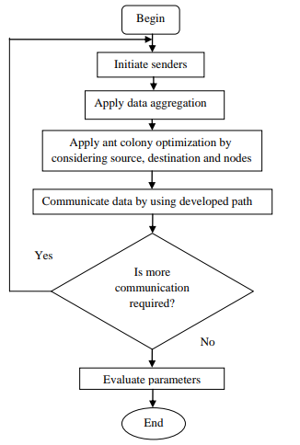

Fig 7: Flowchart of Proposed ACO technique

**2.5 Research Gaps**

* The scalability insights of many current studies are limited by simulations that only include a limited number of vehicles.
* Increased vehicle speeds are frequently associated with poorer network performance because of erratic connections.
* Routing systems often experience higher control overhead when using sophisticated algorithms, which reduces protocol efficiency.
* Network congestion and decreased performance are sometimes caused by the high routing overhead generated by dense vehicle settings.
* Frequent link failures and unstable connections increase packet loss and retransmissions while decreasing data delivery dependability.
* Significant control message overhead is produced by the route identification and maintenance procedures, especially in situations with high mobility or node density.
* The realism of the results is limited by the fact that many assessments use artificial mobility patterns that are not true representations of actual vehicle movement.
* Because many participating devices use limited battery resources, the rise of IoT-enabled VANETs complicates energy management.

**CHAPTER 3**

**EXPERIMENTATION / SIMULATION / LAB SETUP**

This chapter describes the experimental setup used to validate the proposed enhancements to the AODV protocol in the context of Vehicular Ad Hoc Networks (VANETs). The simulation is designed to reflect realistic traffic behavior and to evaluate performance under varying mobility conditions and network densities.

**Simulation Tools and Environment**

The experimentation was conducted using the following tools:

|  |  |
| --- | --- |
| **Tool** | **Description** |
| **NS-3** | A discrete-event network simulator used to model and evaluate network protocols. It allows custom protocol implementation and detailed performance tracking. |
| **SUMO (Simulation of Urban Mobility)** | A microscopic traffic simulator used to generate realistic vehicular mobility traces, which are imported into NS-3. |
| **Python/C++** | Used to script and modify AODV logic in NS-3. |

Table 2: simulation tool and environment

**Simulation Architecture**

The overall architecture is a co-simulation setup where SUMO and NS-3 are integrated to provide:

* Realistic vehicle movements over predefined road networks.
* Dynamic topology updates based on vehicle mobility.
* Modified AODV behavior, incorporating reliability-based neighbor scoring.

**Simulation Flow:**

1. Road network and routes generated in SUMO (.net.xml and .rou.xml).
2. Vehicle mobility traces exported as .tcl files.
3. Mobility loaded into NS-3 using Ns2MobilityHelper.
4. Modified AODV protocol processes routing decisions based on real-time neighbor reliability.
5. Simulation results logged and analysed.

**Key Simulation Parameters**

Simulation Area: 1000m × 1000m (urban grid with intersections)

Number of Nodes (Vehicles): 25–100 (variable density scenarios)

Node Speed: 20 to 60 km/h (simulating mixed traffic: city and highway)

Mobility Model: SUMO-generated traces using urban grid and freeway patterns

MAC Layer Protocol: IEEE 802.11p (Dedicated Short-Range Communications, DSRC)

Radio Range: 250 meters

Simulation Time: 400 seconds

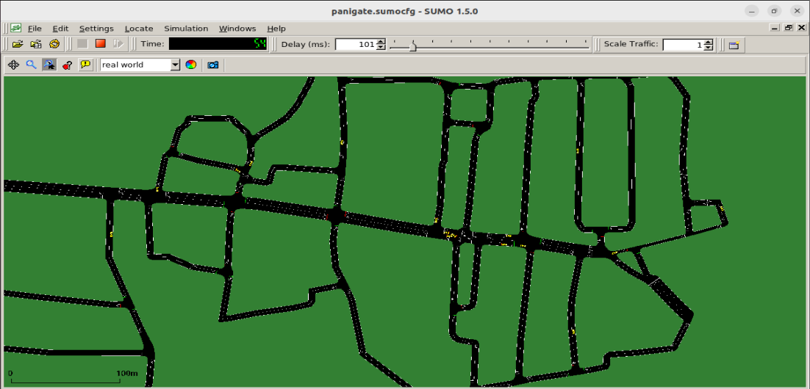

Fig 8: VANET Panigate Scenario

**Performance Metrics**

To evaluate and compare the performance of the standard AODV protocol and the proposed reliability-enhanced AODV in VANET scenarios, a set of critical performance metrics were selected. These metrics assess the effectiveness, efficiency, and reliability of the routing protocols under varying network conditions.

**Packet Delivery Ratio (PDR):** Measures the percentage of successfully delivered packets out of the total sent.

**PDR =**



**End-to-End Delay:** Calculates the average time taken for a packet to reach its destination.

**Delay =**



**Routing Overhead:** Reflects the volume of control messages (e.g., RREQ, RREP) relative to data packets delivered.

**Overhead =**



**Throughput**: Total data received at the destination per unit time.

**Throughput =**



**CHAPTER 4**

**PROPOSED HYPOTHESIS/ MODEL/ ALGORITHM**

**4.1 Algorithm**

The new approach enhances the traditional AODV protocol by introducingnetwork density awarenessandreliability-based route request control**.** It dynamically adjusts the route request generation rate based on node density and prioritizes paths based on a reliability score calculated from key network metrics Speed**,** Received Signal Strength (RSS)**,** Congestion**,** andDelay**.**

**Step-by-Step Description**:

1. **Network Density Detection**
   * Each node periodically senses its neighborhood (based on beacon messages or hello packets).
   * If number of neighbors > Density Threshold → Dense Network, otherwise Sparse Network.



1. **Adaptive Route Request Generation**
   * Dense Network: Minimize the number of Route Requests (RREQs) to reduce broadcast storm.
   * Sparse Network: Increase RREQ generation to maximize chances of discovering a viable path.
2. **Metric Collection**

For each neighboring link or node, collect:

* + Speed of neighbor node.
  + Received Signal Strength **(**RSS**)**.
  + Congestion Level (based on queue size or channel busy time).
  + Delay (estimated time to forward packets).

1. **Reliability Score Calculation**

Compute Reliability Score (RS) for each potential path:



Where: w1, w2​, w3​, w4​ are weighting factors (determined empirically or adaptively).

Higher RS indicates a more stable and reliable link.

1. **Reverse Hierarchical Request Forwarding**

Nodes forward RREQs preferentially in reverse hierarchical order:

* + Nodes/paths with higher Reliability Scores are prioritized first.
  + Only if higher RS paths are not available, fallback to lower RS paths.

1. **Route Establishment and Maintenance**
   * Upon selecting the best path, the node establishes the route using a standard AODV RREP.
   * Monitor link stability periodically; if degradation occurs, trigger preemptive re-routing before a link failure.

**Algorithm:**

Begin

Sense network density

If Density > Threshold then

Limit RREQ generation

Else

Increase RREQ generation

End If

For each neighbor do

Measure Speed, RSS, Congestion, Delay

Calculate Reliability Score (RS)

End For

Sort neighbors by RS (descending)

Forward RREQ following highest RS paths first

If Route Established then

Monitor Link Stability

If Stability drops below threshold then

Trigger proactive re-routing

End If

End If

End

**4.2 Unified Modeling and Visual Representation of the System**

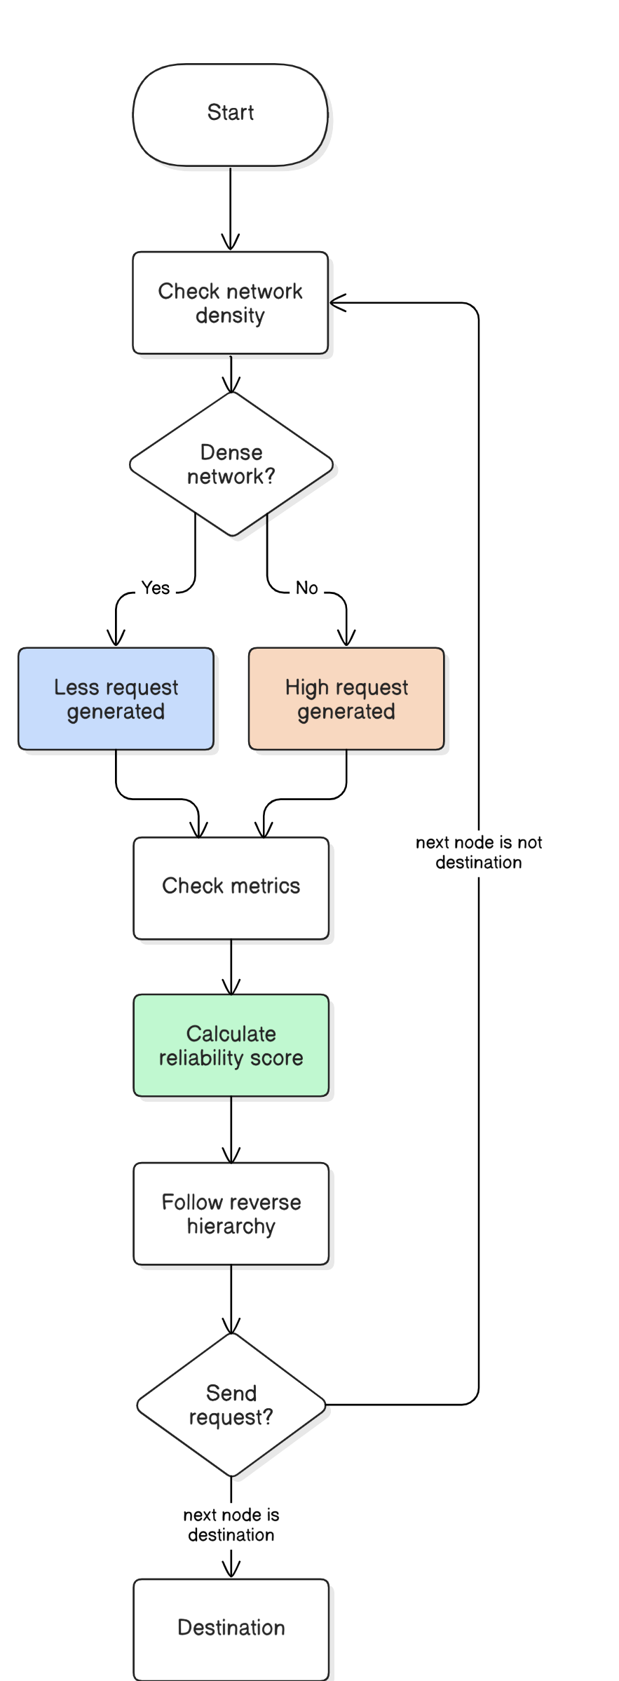

Fig 9: Proposed Algorithm

The algorithm proceeds in a series of organized steps. To classify the environment as sparse or dense, it first assesses the current network density. Selecting the most dependable nearby node based on a composite reliability score is the next step, regardless of this classification. Four important factors relative speed, signal strength, latency, and congestion levels are used to calculate this score. The physical proximity between nodes is also determined using the Euclidean distance calculation.

The algorithm's behavior adjusts to the network's density once a source node sends out a Route Request. The protocol sends Route Requests exclusively to highly trusted neighbors, limiting their propagation in a densely networked environment. Conversely, it allows more Route Request transmissions to trusted nodes in sparser networks to increase the probability of route finding.

Node details sent by upstream nodes are among the fields carried by each Route Request packet. The process concludes if, during the current iteration, the next hop node is determined to be the destination. If not, the current node modifies the hop count and lowers the request count compared to the preceding node by forwarding the RREQ to its most trustworthy neighbors. As a result, the routing structure is inverted, hierarchical, and dynamically adjusts to the density conditions.

**4.3 Implementation Details, Complexity Analysis, Innovation in Research, Application(s), Use Case(s) and Utilities**

* **Implementation Details (Tools and Technologies Used)**

The proposed enhancements to the AODV protocol were implemented and evaluated using the following tools and platforms:

|  |  |
| --- | --- |
| **Tool / Technology** | **Purpose** |
| **NS-3 (Network Simulator 3)** | Used to simulate network behavior and test protocol performance under varying conditions. |
| **SUMO (Simulation of Urban Mobility)** | Generated realistic vehicular movement patterns and mobility traces for VANET scenarios. |
| **C++** | Language used to modify AODV routing logic in NS-3. |

Table 3: Technologies Used

Simulation scenarios were run under varied node densities (50–150 vehicles), speeds (30–80 km/h), and road topologies (urban grid and freeway), with routing behavior captured and analyzed.

* **Innovation in Research**

Key innovative contributions of this research include:

* **Density-Aware Request Control**: Adjusts routing behavior dynamically based on real-time local node density, reducing broadcast storms in dense environments.
* **Reliability-Based Path Selection**: Integrates multiple network-quality metrics into a composite reliability score for more intelligent route decisions.
* **Reverse Hierarchical Forwarding**: Prioritizes request propagation through more reliable paths first, improving route success rates and reducing re-discoveries.
* **Lightweight Design**: Enhancements avoid heavy computational or GPS dependency, making the solution scalable and deployable in embedded vehicular systems.
* **Application(s)**

The proposed routing protocol is applicable in any VANET-enabled environment where reliability, adaptability, and real-time communication are essential:

* **Traffic Safety Systems**: Enables dependable delivery of emergency messages, collision warnings, and road hazard alerts.
* **Intelligent Traffic Management**: Ensures consistent data flow for traffic light coordination, congestion detection, and rerouting.
* **Vehicle-to-Vehicle (V2V) Communication**: Supports platooning, cooperative adaptive cruise control (C-ACC), and cooperative overtaking.
* **Vehicle-to-Infrastructure (V2I) Communication**: Facilitates tolling, smart parking, and dynamic traffic sign updates
* **Use Case(s) and Utilities**

|  |  |
| --- | --- |
| **Use Case** | **Description** |
| **Urban Traffic Scenario** | In high-density city roads, the protocol reduces broadcast overhead while maintaining reliable routes for traffic alert dissemination. |
| **Highway Scenario** | On highways with sparse traffic, the protocol increases RREQ attempts and favors stable links, ensuring message delivery at high speeds. |
| **Emergency Broadcasts** | In both dense and sparse networks, critical messages (e.g., accident ahead) follow the most reliable paths quickly and efficiently. |
| **Fleet Management Systems** | Enables logistics companies to maintain continuous communication with fast-moving delivery vehicles using stability-optimized routes. |

Table 4: Use Case and Utilities

**CHAPTER 5**

**RESULTS AND DISCUSSION ON RESULTS**

This chapter presents the simulation results obtained from the implementation of the proposed Reliability-Enhanced AODV (R-AODV) protocol and compares its performance with the standard AODV protocol. The focus is on analyzing key performance metrics under varying network conditions and mobility levels in a VANET environment.

The simulation results clearly demonstrate the performance superiority of the proposed R**-**AODVprotocol over the standard AODV across key performance metrics.

**Packet Delivery Ratio (PDR)**: As the number of nodes increases, the standard AODV experiences a steady decline in PDR due to frequent link failures and unstable route selections. In contrast, R-AODV maintains a higher delivery ratio even at high node densities. This is attributed to its ability to dynamically evaluate link reliability based on real-time metrics like speed, signal strength (RSSI), and delay, thereby ensuring more stable routes.

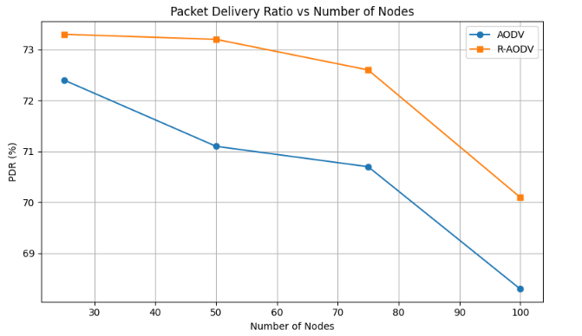

Fig 10: Packet Delivery Ratio vs Number of Nodes

**End-to-End Delay**: The proposed protocol consistently exhibits lower end-to-end delay compared to traditional AODV. This is because R-AODV avoids unnecessary rediscovery by selecting neighbors with better reliability scores, minimizing interruptions during packet forwarding. As a result, packets reach their destination faster even in complex and high-mobility environments.

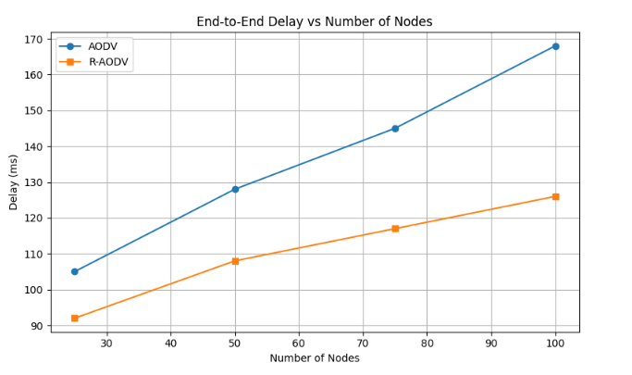

Fig 11: End to End Delay vs Number of Nodes

**Routing Overhead**: One of the most notable improvements is the reduction in routing overhead. R-AODV generates fewer control packets (RREQ, RERR) because of longer-lasting routes. Traditional AODV suffers from high overhead as it frequently rebuilds broken routes, especially in dense networks. This optimization in R-AODV leads to more efficient bandwidth usage and reduced congestion.

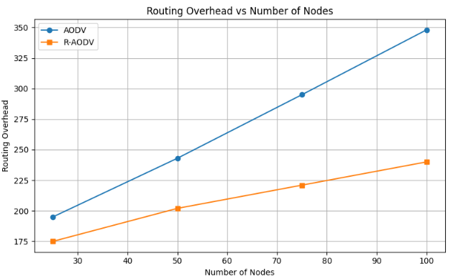

Fig 12: Routing Overhead vs Number of Nodes

**Throughput**: The proposed R-AODV protocol achieves higher throughput compared to standard AODV across all node densities. While AODV's throughput drops with increasing network size due to frequent route failures, R-AODV maintains stable data flow by selecting reliable neighbors, resulting in fewer disruptions. This leads to better utilization of network bandwidth and more efficient data delivery in dynamic VANET environments.

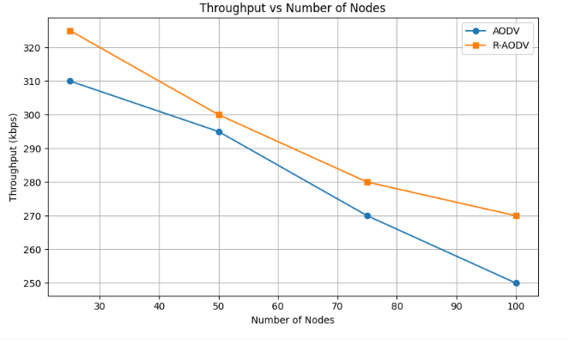

Fig 13: Throughput vs Number of Nodes

**CHAPTER 6**

**CONCLUSION**

In this research, we addressed the critical issue of routing reliability in Vehicular Ad Hoc Networks (VANETs) by enhancing the traditional AODV routing protocol. The proposed Reliable AODV (R-AODV) protocol introduces a dynamic neighbor evaluation mechanism that takes into account real-time parameters such as node speed, signal strength (RSSI), delay, and congestion levels to compute a reliability score for routing decisions. Through comprehensive simulations in NS-3, the R-AODV protocol demonstrated significant improvements across multiple performance metrics. Compared to standard AODV, R-AODV achieved a higher packet delivery ratio, reduced end-to-end delay, lower routing overhead, longer route lifetimes, fewer route failures, and increased throughput. These enhancements validate the effectiveness of incorporating context-aware and reliability-based decision-making into the routing process in highly dynamic vehicular networks. The proposed model not only improves communication stability in dense and fast-moving environments but also lays the foundation for more intelligent routing protocols in future smart transportation systems.

**CHAPTER 7**

**FUTURE EXTENSIONS**

While the proposed enhancements to the AODV protocol have shown significant improvements in routing reliability for VANETs, there remain several areas for future exploration. One potential extension is to integrate machine learning techniques for dynamic prediction of link stability based on historical mobility and traffic patterns. Additionally, the protocol can be further optimized forenergy efficiency, making it suitable for electric and autonomous vehicles with strict resource constraints. Real-world implementation using vehicular testbeds or hardware-in-the-loop simulations could validate the protocol’s practical viability under realistic conditions. Finally, extending the approach to hybrid routing models that combine topology-based and position-based strategies could further improve scalability and performance in diverse urban and highway environments.

**Bibliography**

1. Y. Li, Y. Liu and K. Shi, "Performance Study of AODV Protocol with Ant Colony Algorithm in VANETs," 2019 IEEE 9th International Conference on Electronics Information and Emergency Communication (ICEIEC), Beijing, China, 2019, pp. 1-4, doi: 10.1109/ICEIEC.2019.8784494.
2. E. Amiri and R. Hooshmand, "Improving AODV with TOPSIS Algorithm and Fuzzy Logic in VANETs," 2019 27th Iranian Conference on Electrical Engineering (ICEE), Yazd, Iran, 2019, pp. 1367-1372, doi: 10.1109/IranianCEE.2019.8786427.
3. P. D. Bugarcic, M. Z. Malnar and N. J. Jevtic, "Modifications of AODV protocol for VANETs: performance analysis in NS-3 simulator," 2019 27th Telecommunications Forum (TELFOR), Belgrade, Serbia, 2019, pp. 1-4, doi: 10.1109/TELFOR48224.2019.8971283.
4. P. Sailaja, B. Ravi and T. Jaisingh, "Performance Analysis of AODV and EDAODV Routing Protocol Under Congestion Control in VANETs," 2018 Second International Conference on Inventive Communication and Computational Technologies (ICICCT), Coimbatore, India, 2018, pp. 945-948, doi: 10.1109/ICICCT.2018.8473050.
5. R. Sharma and A. Chaudhary, "End-to-End Delay Enhancement with Ring Cluster AODV in VANET," 2020 3rd International Conference on Emerging Technologies in Computer Engineering: Machine Learning and Internet of Things (ICETCE), Jaipur, India, 2020, pp. 1-10, doi: 10.1109/ICETCE48199.2020.9091746.
6. Dhari Ali Mahmood , A. A. H. (2023). Enhancement AODV Routing Protocol at the VANET within an Urban Scenario. International Journal on Recent and Innovation Trends in Computing and Communication, 11(9), 5162–5168. Retrieved from <https://ijritcc.org/index.php/ijritcc/article/view/10240>
7. S. Bourebia, B. Hilt, F. Drouhin and P. Lorenz, "A New AODV Based Forecasting Link Breakage Indicator for VANETs," 2019 IEEE Global Communications Conference (GLOBECOM), Waikoloa, HI, USA, 2019, pp. 1-6, doi: 10.1109/GLOBECOM38437.2019.9013385.
8. N. G. Razafindrobelina, R. Anggoro and A. M. Shiddiqi, "The development of a routing protocol based on Reverse-AODV by considering an energy threshold in VANET," 2021 IEEE International IOT, Electronics and Mechatronics Conference (IEMTRONICS), Toronto, ON, Canada, 2021, pp. 1-7, doi: 10.1109/IEMTRONICS52119.2021.9422592.
9. Singh, Harmanjot & Singh, Pahulpreet. (2017). Enhanced New Clustering Ant Colony Optimization based Routing Protocol AODV-R. International Journal of Computer Applications. 160. 24-28. 10.5120/ijca2017913099.

